
Development Request
Aria Systems
Material Purchase Order Form customized

Custom Program #: 102685
Customer: BRA14 - BRATEX

New Program Template Description

New Program Template

Purchase Order Form
Product: | Aria2.7
Module: | MA
Customer name: | Bratex (BRA14)
Installed Modules: | AL, AR, AS, AP, EB, CRM, GL, IC, MA, MF, PDM, RM, SM, SO, SR, UP
Parameters setting: | They are set-up to use Extended Size Scale. They have GL linked to the system. They are setup to use Lot costing and keeping track of Rolls for MA module. They are also setup to use Dyelots for MA and IC (finished goods). They are also using Multi Currency.

System Setting Report:
We need to get a list of all system settings.
You can export the system settings through Aria 2.7 as follows:
Select the menu “User” then the Menu Option “Settings” then the submenu option “Export System Settings” then finally write down the file name to which settings will be saved.

Details Section
Report Name: Material Purchase Order Form
Report Objective: Change the layout of the report and also add some new fields to the report and also the selection grid of the report.

Existing Initial situation: Purchase Order for Materials. (Form A) Customized

Description (Processing): We need to modify the Purchase Order form (A) by changing the layout of the form and also adding new fields to the Report and also Selection Grid. This customization report is also going to tie into other customizations that are going to be done in the system. This report will also take into consideration the Revision # of that Purchase Order if a modification was done to that PO.

Selection Grid:

We will keep all the fields from our Standard (form A) form in Aria. We will only add these new options to that Selection Grid:

- “MRP# “ – This will be an “Inlist” field where the user will be able to browse by MRP #. If the user chooses to print by MRP# then all the Material Purchase Orders that are flagged with that MRP number will print in that Range. (MRP# will be an enhancement that will be done to the program that will give the user the ability to save an MRP “Requirement Report” at the time of printing. Aria will then give the user a sequential number for that save MRP. That MRP code will also be available for the Purchase Order Screen where PO’s created related to that MRP will be saved in the Purchase Order Header.) This will in turn give the user the flexibility to print by MRP# and all those Purchase Order in the system that have that MRP# will print in that Range
- “Customer” – The user will have the ability to filter PO’s created for Materials that are needed to supply a Sales Order for a Customer. On the Purchase Order they will assign a Customer account code and then they can filter that Report by that Customer Account Number
- “Transaction#” – This field will remain the same. The only difference is that at the moment of printing the Form the program will check to see if there is a value under the Revision field for that Purchase Order. If there is a value then the report will print that value as the Purchase Order number. If there is no value on the field then the report will print the Purchase Order number.

Report fields:

- “MRP#” – This field will print the MRP# that was saved with that Purchase Order in the system
- “Supplier Code” – This will print the Supplier Code for that Item that they are purchasing. This will also come from a customization that will be done to the Purchase Order screen and Material Screen. The user will have the capability to reference any raw material in the system with that of the supplier. If the user created a reference item number for that Material then this field will be displayed
- “Supplier Color” – This will print the Supplier Color Code that they created for their materials. If the user created a reference with Aria Color and Supplier Color then this field will print the Supplier Color Code
- “Item Delivery Date” – This field will display the Delivery Date of the item that could be different then the Completion Date of the Purchase Order. This field will also come from a Customization that will be done for the Material Purchase Order screen where the user has the ability to assign a different delivery date for each Material on that PO
- “Customer” – This field will display the customer “Account Name” that the Material Purchase Order was created for. This also is coming from an enhancement that is being done on the Material Purchase Order Screen where the user can select an Account code in the system.
- “Signed by and Date” – This field will print to allow the user or whom every to sign this Purchase Order form and enter the date that they signed it.
- “Purchase Order” – This field will print either the Purchase Order number of the PO or the Revision # (this is a new customization that was done for the Purchase Order Screen). At the time of previewing or printing the report the program will check to see if there is any value on the Revision# field for that Purchase Order. If there is a value then the report will print that value on the Purchase Order form. If there is no value then the report will print the Purchase Order number.

Report Layout:
The report will first check to see if there is a Revision # assigned to that Purchase Order. If empty it will print the Purchase Order number else it will print the Revision #.
We will hardcode Bill To: and Attn: Accounts Payables fields on the report. We will then print the Company Address information as our Standard PO (Form A) except the fonts are a little bigger and also in bold

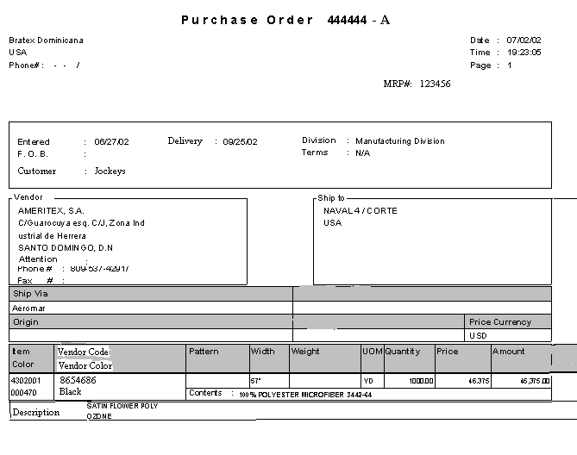
The Delivery Date for each line item will be displayed in this area. Please note that you can reduce the size of the vendor code and color in order add more space here
-01
Bill To:
Attn: Accounts Payables
Company Name
Company Address
Phone Number

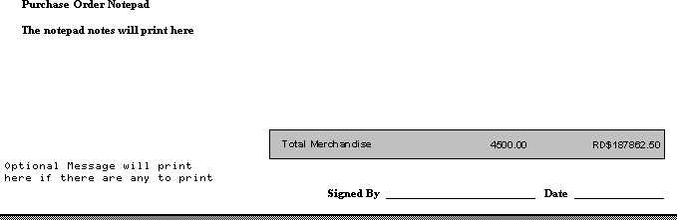

*****NOTES

- Please note that the most of the information on this form is the same as our standard Form (A). Some of the information on this report has just been moved around on the form layout
- Notice that the FREIGHT, TAX, and QUOTA fields are not on this form. As per the Purchasing Department they requested not to print this information because it is not needed.
- Notice that the Description was moved from the Right of the “Item Color” field and placed as the last line. To the right of the “Item Color” field will be the new fields “Vendor Code and Vendor Color” fields.
- Under the “F.O.B.” field will be another new field called “Customer” the Customer Name will be displayed here.
- The “MRP#” field is the new field that will be picked up from the Purchase Order header field.
- As far as the “Vendor Code” and “Vendor Color” fields you will have to go to the new reference fields that are being created for this customer that is going to link their Aria material Item number with the Supplier Item # and Color
- The Purchase Order field will print the Revision # if it exists for that Purchase Order else it will print the Purchase Order number.
- “Bill To” and “Attn: Accounts Payables” fields are hard coded on the PO form. Please also note that the Fonts are bigger and also in Bold. We will then print the Company Information that Normally prints on our Standard PO (Form A) but this will also be in bigger and Bolder Fonts

Please take the time to read the other custom programs that are going to be created for this customer that relates to the Materials and Materials PO so that you can better understand all the changes being done.

Development Cost | $ 750
Customer signature
  Date signed
Payment Terms | 50 % due upon signing.  50% due upon delivery of the project.  (No work on this project will begin until the deposit is received)
Estimated completion time | 4 –6 weeks from signing and receipt of 50% of payment

